|  |  |  |
| --- | --- | --- |
| Product Catalogue | Adjustable resistor / potentiometer |  |
| Resistance value | 200kΩ |  |
| Precision | ±10% |  |
| Temperature coefficient | ±100ppm/℃ |  |

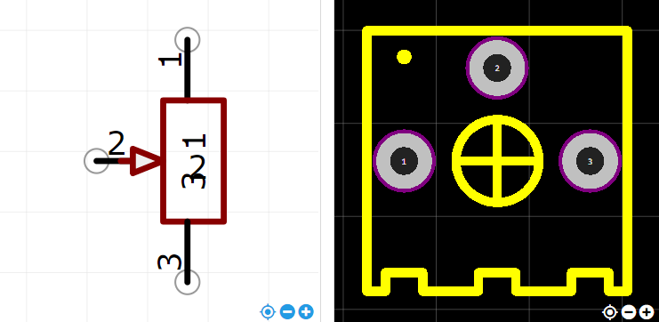

<https://item.szlcsc.com/112883.html>